**data** cars ;

SET sashelp.cars;

**RUN**;

TITLE "This is a revision practice";

FOOTNOTE "Done on &sysdate9. %sysfunc(time(), timeampm.)";

LIBNAME mydata "work" ;

/*Data has been subsetted*/

/*ODS pdf file="Frequences.pdf";*/

**data** cars;

length n **3**; ;

set work.cars;

LABEL Make ="This is the cars make"

Cylinders = "This is the model type";

Momentum =cylinders * Wheelbase;

IF cylinders =**8** then cylinders =**.**;

IF MSRP >= **35000**;

IF Horsepower <=**240**;

n=_n_ ;

**proc** **sort**; by n;

**PROC** **PRINT**; VAR Momentum cylinders Wheelbase;

**PROC** **FREQ**; TABLES /*make*/ cylinders wheelbase/*MSRP Horsepower*/;

**proc** **univariate**; VAR msrp;

**proc** **gchart**; VBAR Make/ Discrete Type=PCT;

**proc** **gchart**; VBAR msrp/ Type=PCT;

**RUN**;

ODS pdf close;

TITLE "";

FOOTNOTE "";

**goptions border xpixels=460 ypixels=500; /* */**

**axis1 label=(angle=90 "Models Produced"); /* */**

**axis2 label=("Vehicle Type");**

**title "Models Produced By Vehicle Type and Origin"; /* */**

**footnote "Data: SASHELP.CARS";**

**proc gchart data=sashelp.cars; /* */**

**vbar3d type / /* */**

**subgroup=origin**

**type=freq freq**

**shape=cylinder space=1**

**axis=axis1 maxis=axis2 autoref clipref;**

**run;**

**quit; /* */**

**title; /* */**

**footnote;**

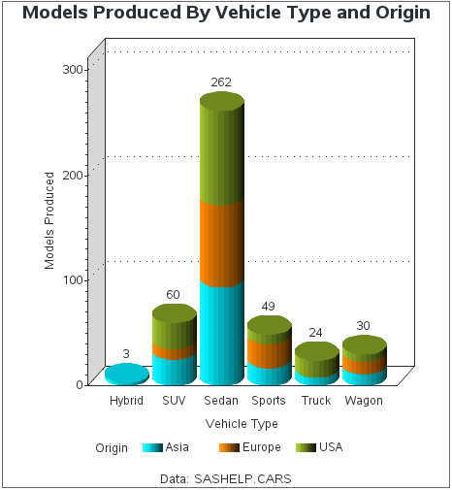

**proc sgpanel** data=sashelp.cars noautolegend;

where origin in("Europe" "USA");

panelby origin;

histogram mpg_highway;

fringe mpg_highway / height=20 lineattrs=(color=red);

**run**;

